### **A Sliceform Egg - Math, Art and Engineering Intersecting at its Best**

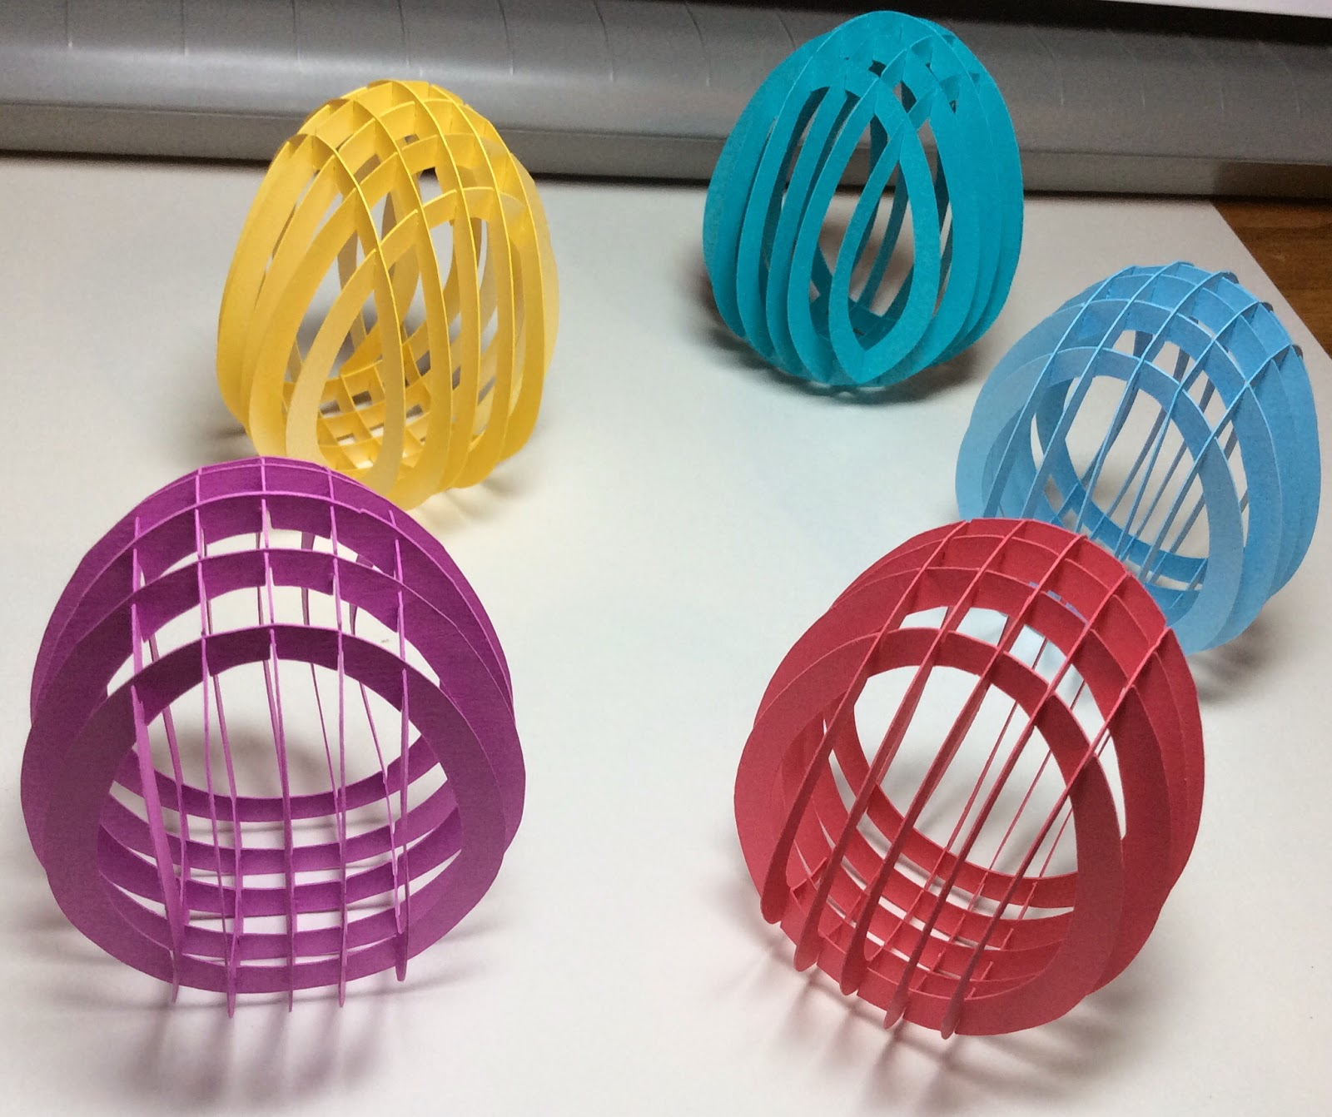

Egg Sliceform

While you might think that this is just a smaller version of the Easter Egg Snow Globe from a previous post, it is not. I could not reduce the size of the egg snow globe because everything including the slits would be reduced. Thus making the slits impossible to use. I created this egg sliceform with two shapes joined together - a circle and a parabola.

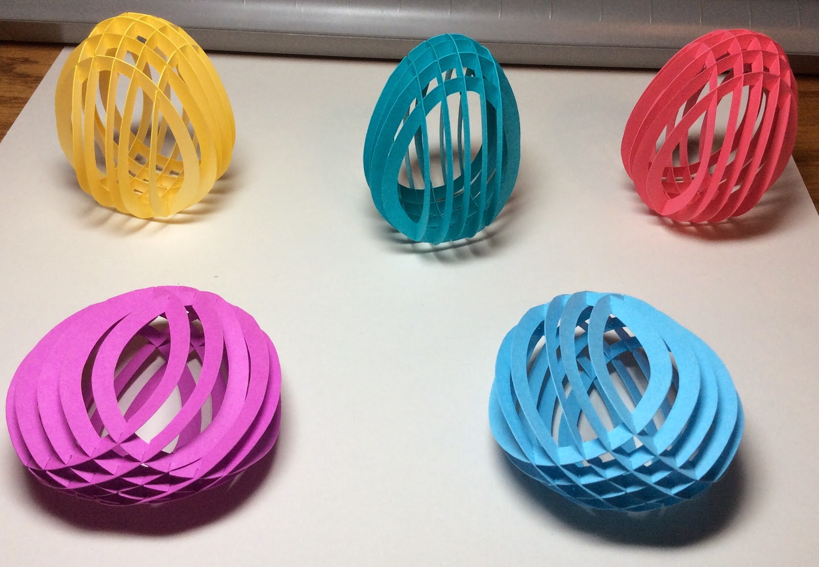

I love how the egg lies flat and the slices intersect.

Math, Art and Engineering intersecting at its Best!